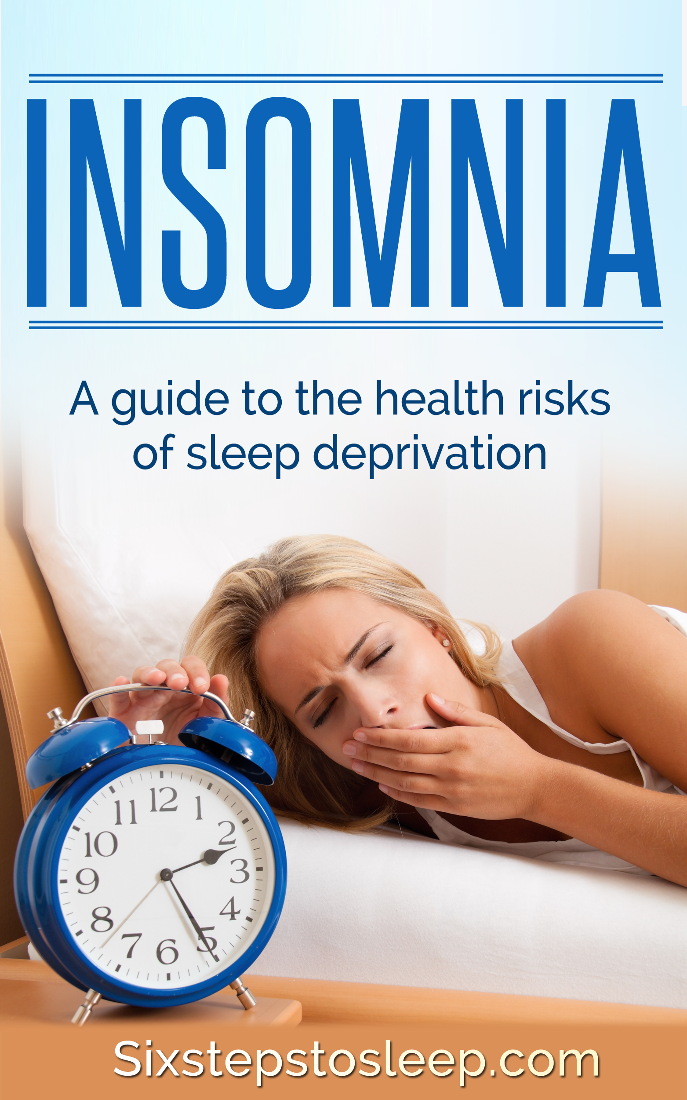

Insomnia
A guide to the health risks of sleep deprivation

SixStepsToSleep.com

Second Edition © 2015

Table of Contents

1. Introduction

2. What Happens When You Don’t Get Enough Sleep
- Effects on the Body
- Effects on Mood

3. Sleep Deprivation: Hormones and Metabolism
- Sleep and Obesity
- Sleep and Diabetes
- Sleep and the Immune System
- Sleep and Cardiovascular Disease

4. Understanding Insomnia

5. How To Cure Insomnia
- Prescription Sleep Medications (Sleeping Pills)
- Natural Cures for Insomnia

6. Summary

1. Introduction

The consequences of sleep deprivation are far reaching. Lack of sleep affects physical and mental health, and causes an increased risk of human error that can be fatal.

Two well-publicized examples of this were the 1989 Exxon Valdez oil spill, and the1986 NASA Challenger shuttle explosion. Both accidents were caused by fatigue linked to lack of sleep.

In addition to such major accidents, drowsiness in sleep-deprived drivers is said to be the likely cause of more than 100,000 crashes, 71,000 injuries and more than 1,500 deaths each year.

Many airplane crashes have been linked to pilot tiredness due to excessive flying hours across different time zones. This evidence points to one simple conclusion; lack of sleep presents a very real danger to human life.

In terms of physiological health, studies show a growing correlation between sleep duration and a variety of serious health problems, including obesity, diabetes, hypertension and depression. On a more personal level, lack of sleep affects our quality of life, leaving us feeling miserable, lethargic and stressed.

With these things in mind, it is important that we begin to understand the biology of sleep; why we need sleep and how we can better the quality of our sleep to improve overall health and safety.

Scientists now know that sleep isn’t simply about rest and recovery. Sleep is essential in helping maintain mood, memory and cognitive performance. Sleep also plays a pivotal role in the normal function of the endocrine and immune systems. In short, the less sleep a person has, the more likely their health is to decline.

However, even though poor quality sleep is endemic, with at least 40 million Americans suffering sleep problems, 60 percent of the adult population has never been asked about their sleeping habits by a physician.

With a growing pool of knowledge regarding the negative consequences of sleep deprivation, improving sleep quality must become a health priority in our lives.

2. What Happens When You Don’t Get Enough Sleep

Through extensive animal research, scientists know that that sleep is essential for survival. In short, a person cannot survive indefinitely without sleep.

When we sleep, protein production takes place that provides the necessary building blocks for cell growth and repair. The body recovers from stress damage and the damage caused by ultraviolet rays, and immunity is boosted. Without sufficient rest the body is weakened, exposing us to greater risk of poor health.

Effects on the Body

When humans don’t sleep properly, physiological and cognitive functions are negatively impacted. The affected functions include memory and attention, complex thought, motor response and emotional control.

One particular clinical study showed that subjects who stayed awake for up to 19 hours scored substantially worse on performance and alertness than those who were legally intoxicated. Other studies have demonstrated similar results:

- After one night of total sleep deprivation, subjects scored significantly lower on tests of judgment, simple reaction time, explicit recall and inverse word reading.

- Daytime alertness and memory are impaired by sleep deprivation, especially when sustained over a few nights.

- Getting three, five or less than seven hours of sleep a night for seven consecutive days can significantly impair alertness and motor performance.

(Source: National Sleep Foundation – Sleep-Wake Cycle, 2006)

Effects on Mood

After a bad night’s sleep, it is normal to feel pretty miserable. Studies have shown that lack of sleep considerably affects mood, causing anger, anxiety and sadness.

A study at the University of Pennsylvania found that when subjects were allowed to sleep just 4.5 hours a night for one week, scores for mood declined steadily during the testing period.

When participants were allowed to get enough sleep, their mood scores improved dramatically. During the test period subjects said they felt stressed, angry, sad and mentally exhausted.

But sleep deprivation does far more than make us feel grumpy and a little slower to react. In the past few years, investigators have found that sleep deprivation may have harmful consequences for our immune system, contributing to serious illnesses such as obesity, diabetes and hypertension.

3. Sleep Deprivation: Hormones and Metabolism

When we sleep, the body secretes essential hormones that regulate energy and control metabolic and endocrine functions.

Sleep deprivation dampens the production of thyroid-stimulating hormones and increases blood levels of cortisol, a hormone that contributes to wakefulness. Growth hormone is also secreted during sleep, which contributes to childhood growth and helps regulate muscle mass in adults.

This means that without sleep the body cannot produce the basic hormonal functions required for the body to operate properly.

Sleep and Obesity

The fact is we are sleeping less than ever before, and it is affecting our health. The average night’s sleep decreased from about nine hours in 1910 to about 7.5 hours in 1975, and in the modern era millions of shift workers average less than five hours of sleep per working day.

Research has shown that this global sleep deprivation trend is having an impact on the obesity and diabetes epidemics.

According to the Centers for Disease Control and Prevention, about 65 percent of Americans are overweight or obese. Of course, caloric intake is a major factor in rising obesity, but science has proven a link between lack of sleep and weight gain.

One interesting study shows that lack of sleep imbalances leptin and ghrelin, two hormones responsible for the control of feeling hunger and fullness. Ghrelin is produced in the gastrointestinal tract and stimulates appetite; leptin on the other hand signals to the brain when a person is full.
Lack of sleep causes these two hormones to become imbalanced and operate ineffectively. When a person is sleep-deprived, leptin levels drop and ghrelin levels rise; subsequently appetite increases, leaving a person feeling hungry after they have eaten and causing them to crave further calories.
Sleep and Diabetes

Obesity has been directly linked to diabetes, and sleep deprivation linked to impairing sugar metabolism.

A study conducted at the University of Chicago in 1999 found that a sleep debt accumulated over a matter of days is capable of impairing sugar metabolism and disrupting hormone levels.

After restricting the sleep of 11 healthy young adults to just four hours per night over several nights, the group’s ability to process blood glucose declined considerably – in some cases to a pre-diabetic state, prompting the subjects’ bodies to produce more insulin.

Sleep and the Immune System

The age-old theory that sleep helps speed up recovery from illness may not be just an old wives’ tale after all.

Studies have shown that lack of sleep has a negative effect on the immune system; with one study proving that flu vaccination patients subjected to sleep deprivation took longer to attain immunity.

During the study, flu shots were administered to men who had been restricted to just four hours of sleep for four nights in a row, and to those who had slept normally.

Ten days after vaccination, those in the sleep-deprived group had a substantially lower immune response compared with those who got adequate sleep, and produced less than half as many flu-fighting antibodies.

(Source: National Sleep Foundation – Sleep-Wake Cycle, 2006)

Sleep and Cardiovascular Disease

Long and short-term sleep deprivation is now known to contribute to cardiovascular disease. Lack of sleep causes increased blood pressure and increased risk of stroke, and is associated with a rise in blood pressure during the night that lasts through the following day. Evidence also suggests increased risk of coronary heart disease in women who don’t get enough sleep.

4. Understanding Insomnia

All scientific evidence shows that sleep deprivation presents considerable health risks on a number of levels, yet statistics show that approximately 30 percent of the American population suffers from a form of insomnia.

But what is insomnia and how can it be cured?

Insomnia is diagnosed when a person has difficulty initiating or maintaining sleep, that is either not being able to fall asleep, waking too early and not being able to get back to sleep, or waking persistently through the night and subsequently feeling unrested and lethargic.

Insomnia symptoms include daytime fatigue, impaired mood and judgment, poor performance and an increased likelihood of accidents at home, in the workplace and while driving.

For some insomnia is temporary, perhaps caused by jet lag, work stress, a major life change such as the loss of a relationship, environmental factors like excessive noise or by consuming too much caffeine or sugar before bed. But some people go on to develop chronic insomnia, which is generally diagnosed in those who struggle to sleep for three nights in a given week, for a month or longer. Chronic insomnia is often related to an underlying medical or psychiatric condition such as depression or anxiety, but is commonly caused by a persistent, unhealthy sleep-wake cycle.

5. How To Cure Insomnia

The approach to treatment for insomnia generally falls into two categories: pharmacologic and behavioral.

Prescription Sleep Medications (Sleeping Pills)

An estimated 10% of the American population takes some form of medication to achieve a state of sleep. However, few people who take sleeping pills really understand how the pills work, and even fewer understand that sleeping pills do not cure insomnia.

Benzodiazepines (also known as benzodiazepine receptor agonists) were the main pharmacologic treatment for insomnia up until the ‘90s. These included popular drugs such as Flurazepam, Triazolam, and Temazepam.

Benzodiazepines are central nervous system depressants that are considered by the majority of physicians to be more active in reducing anxiety, inducing muscle relaxation and inhibiting convulsions than in promoting sleep. Many people experience side effects when taking benzodiazepines, such as memory loss, rebound insomnia and addiction.

In the modern era, a benzodiazepine named Xanax has become a popular sleep aid because it is easily bought over the Internet without prescription. Xanax contains Alprazolam, a substance that increases the activity of GABA in the brain and therefore increases its calming effect on the brain. This helps decrease anxiety and panic by causing drowsiness and relaxation of the muscles, which is of course conducive to sleep. However, Xanax is highly addictive, and is only recommended for short-term use. It is by no means a cure for insomnia and should not be self-prescribed.

In the ‘90s, nonbenzodiazepines (or nonbenzodiazepine receptor agonists) were introduced. These sleeping pills, which include Zolpidem and Zaleplon, have the advantage of being much shorter-acting compounds with less likelihood for daytime sleepiness or impairment of memory. However, they may still cause side effects in some people, including rebound insomnia, addiction, drowsiness, dizziness, lightheadedness and difficulty with coordination.

The Danger of Sleeping Pills

Sleeping pills are highly effective in helping people fall asleep quickly, and in helping people stay asleep for the recommended eight hours. However, sleeping pills are generally addictive and ineffective at curing insomnia, with the majority of patients experiencing rebound insomnia.

Another side effect of sleeping pills is sleepiness, which is often far more difficult to cope with than the sleepiness caused by lack of natural sleep. So while a person may sleep fall asleep quickly and stay asleep for the required duration when taking sleeping pills, their quality of life (daytime) is impaired by sleepiness, which in turn affects cognitive ability and renders the medication largely counterproductive.

Recent evidence has highlighted serious health issues relating to the regular consumption of sleeping pills. A study headed up by Dr. Daniel Kripke, of the Scripps Clinic, compared 10,529 people that took sleeping pills with twice as many who didn’t.
The study revealed that those taking prescriptions were at a 35% increased risk of cancer compared with the non-prescription group. The study proved that the risk of developing lymphoma, lung, colon or prostate cancer associated with sleeping pills was greater than the effect from smoking.

In short, sleeping pills are a short-term fix, not an insomnia cure. Regular consumption of sleeping pills is likely to cause side effects and addiction, and may lead to health problems.

Natural Cures For Insomnia

Considering that sleep is a natural part of the human lifecycle, it seems quite surprising that so many people have trouble sleeping.

That said, the reason for the prevalence of insomnia is quite clear. In the modern day sleep has become less of a priority, much to the detriment of our health. Most people simply don’t allow the body to prepare for sleep properly, or provide the body with a lifestyle and environment conducive to healthy sleep.

The only proven, sustainable cure for insomnia is the practice of good sleep hygiene, which is often accompanied by other holistic therapies such as meditation to help temper stress and anxiety and promote habitual relaxation.

Good sleep hygiene is essential to achieving deep, restorative sleep. Some of the key practices involved include maintaining a regular sleep-wake cycle, avoiding stimulants late in the day, ensuring adequate exposure to natural daylight and maintaining an environment conducive to sleep; dark, cool and noise-free.

Sleep hygiene experts often include behavioral therapy within their programs.

One such therapy is Stimulus-Control, which conditions the patient to solely associate the bed and bedroom with sleep. If unable to sleep, the patient is instructed to get out of bed, and to avoid eating, reading or watching television in bed.

Another pathway is Relaxation Therapy, which includes muscle relaxation, brainwave meditation and breathing techniques. These techniques entrain the brain to fall asleep faster and stay asleep for longer.

Sleep-Restriction Therapy also plays a part in good sleep hygiene. In this practice the patient is required to wake at the same time each day, regardless of the amount of sleep achieved during the night. This results in sleep deprivation, which enables the individual to fall asleep faster the following night, and so on and so forth, subsequently breaking the cycle of habitual insomnia.

No matter how bad the cycle of insomnia, with the correct sleep hygiene methods, the cycle can be broken, the body clock readjusted and the brain remapped to a healthy sleep-wake cycle.

6. Summary

Cutting back on sleep is an extremely common response to the pressure we face in our modern industrial society. But research shows that sleep deprivation disrupts hormonal and metabolic function which, if not addressed, can cause cardiovascular problems, weight gain and psychological issues.

Sleep is a dynamic activity that is as essential to good health as exercise and a good diet. Sleep deprivation is dangerous, and must be addressed quickly to ensure the mind and body function healthily in the long term.

If you are suffering from insomnia, or have recently been struggling to sleep, it is important that you address the underlying issues quickly instead of using pills or other sleep aids to temporarily mask the problem.

My Six Steps To Sleep program, based on my personal 15-year battle with insomnia has helped over 100,000 people cure themselves safely and naturally of insomnia.

The program combines proven good sleep hygiene methodology, cognitive behavioral therapy and brainwave meditation. This powerful three-pronged approach retrains the body to fall asleep faster and sleep deeper for longer, and permanently restores a healthy sleep-wake cycle.

>> Click here to get started & start sleep better tonight <<

All rights reserved. Peter Litchfield / SixStepsToSleep.com 2015 ©. No part of this publication may be reproduced, distributed, or transmitted in any form or by any means, including photocopying, recording, or other electronic or mechanical methods, without the prior written permission of the publisher, except in the case of brief quotations embodied in critical reviews and certain other non-commercial uses permitted by copyright law.

The information for this document was compiled using research studies and information supplied by The National Sleep Foundation (www.sleepfoundation.org) and Peter Litchfield (founder of sixstepstosleep.com).

